**Transmitter PCB layout:**

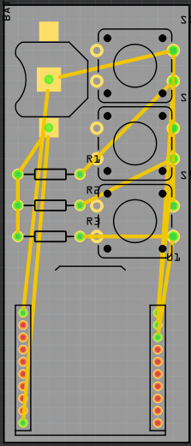

Size: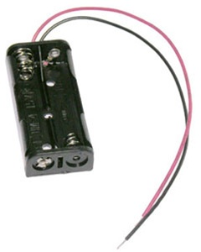

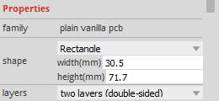

The battery holder size is 2.1" long x 0.97" x 0.50" high,

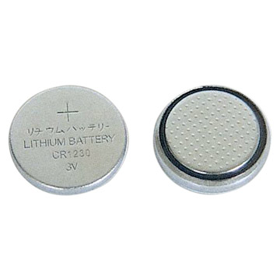

But in this PCB layout, we use the smaller battery,

We are hoping to design an handlebar attachment that only have 3 buttons exposed, while the bottom part could be attached to the handlebar.

